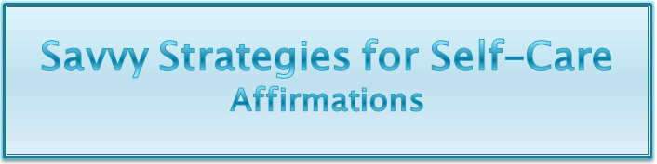

My self is worth taking care of
I am learning to be kind to myself
I love showing kindness to myself and others
I am an unlimited being and I can create anything I want
When I fulfil my own needs, I have the energy to fulfil the needs of others
I love filling up my own energy resources
I enjoy serving others from my overflow
I am learning to say “yes” to myself by saying “no” to too much
Saying yes to myself means I’m healthy enough to help others
I replenish my energy so I can joyfully serve others
My needs are important and I give to myself joyfully
I am learning to receive and give equally
When I say “no”, I give someone else the opportunity to be creative and resourceful
Everyone, including me, is whole, resourceful and complete
Giving myself what I need is easier the more I do it
I am more and more aware of my own needs
I radiate self-esteem, inner peace, love, well-being and happiness
The happier I am, the happier those around me are
The more I take care of myself, the more others respect me
My boundaries help me to protect what’s most important to me
I lovingly care for myself and my body
I lovingly take care of my emotional, mental, spiritual and physical needs
I radiate love and happiness and I fill my own energy tanks
When I am content and fulfilled, it rubs off on those around me
I am responsible for my own well-being. Others are responsible for theirs.
When I rescue someone else, I rob them of their learning and soul path
When I lovingly take care of me, it sets a great example for my children
My children learn about their own self-worth from seeing how I treat myself
Self-care is an investment in my family
When my own energy tanks are filled, I’m resourceful, creative and energetic
When my own energy tanks are filled, I’m fun to be with
I am learning how much joy it brings me to fulfil my needs and feel enthusiastic

Create Your Own Affirmations:

